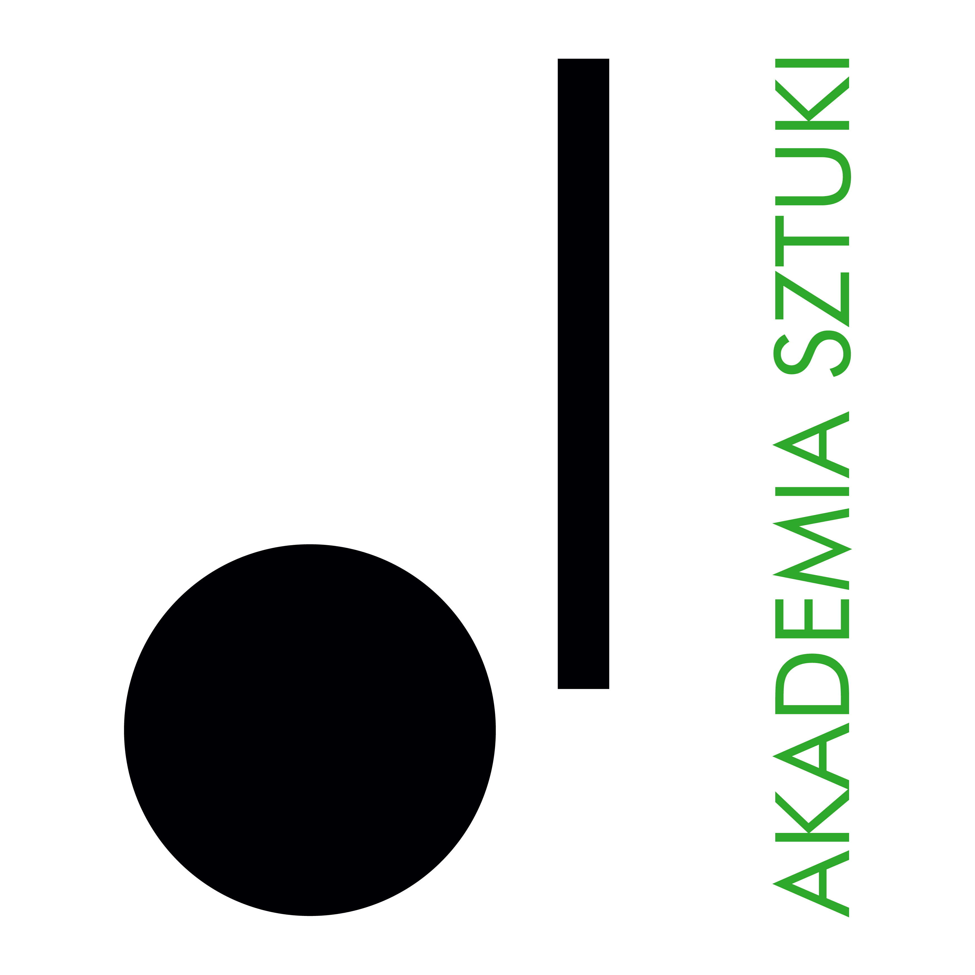

**RECTOR**

**Academy of Art in Szczecin announces an open competition for the position of   
Assistant Professor**

**in the Department of Curating and Exhibiting at the Faculty of Painting**

**The competition may be entered by persons meeting the requirements provided for in art. 113 of the Act of   
20 July 2018 - Law on Higher Education and Science (consolidated text, Journal of Laws of 2024, item 1571, as amended)** **and meet the following eligibility criteria:**

• having at least a doctoral degree

• a record of research and curatorial achievements in the field of visual arts or art studies

• an interest in further academic development

• professional experience gained through curatorial work, including organizing and financing exhibition projects

• experience in higher education teaching

• very good command of the English language

• willingness to undertake regular, on-site teaching duties in Szczecin during the academic year

Required documents:

* application for participation in the competition,
* professional resume and personal questionnaire,
* a copy of the diploma/s of completing master's and PhD studies,
* a candidate in the research and teaching staff category should provide documented evidence of scholarly and/or curatorial achievements.
* a statement that the Academy of Art in Szczecin will be the primary place of work,
* declaration according to art. 113 of the Law on Higher Education and Science**,**
* any additional information (in the form of documents or publications that may be important in assessing additional skills related to the outcome of the competition),
* knowledge of the Polish language is required in the case of foreign applicants

**The deadline for submitting applications is**: **June 1, 2025.**

Documents received by the Academy of Art in Szczecin after the deadline will not be considered (the date of receipt is decisive).

Selected candidates who qualify for the second stage of recruitment will be invited **to an interview.** The candidates will be informed about the date and place of the meeting by e-mail.

**Estimated date for the conclusion of the competition:** **June 15, 2025**

**Announcement of the competition result**: **June 16, 2025**

**Place of submission of documents**: documents will be accepted only in electronic form at: anita.antonczak@akademiasztuki.eu

In the title of the e-mail, please enter: COMPETITION FOR THE POSITION OF ASSISTANT PROFESSOR

Note:

The Academy of Art reserves the right to reject the offer without giving any reason.

The Academy of Art does not provide accommodation for candidates from outside of Szczecin.

The following should be added to the application form: *"I consent to the processing of the personal data contained in my job offer for the purposes necessary for the recruitment process and thereafter, conducted by the Academy of Art in Szczecin, based in Szczecin, in accordance with the Personal Data Protection Act of 10 May 2018 (Journal of Laws of 2018, item 1000, as amended)".*