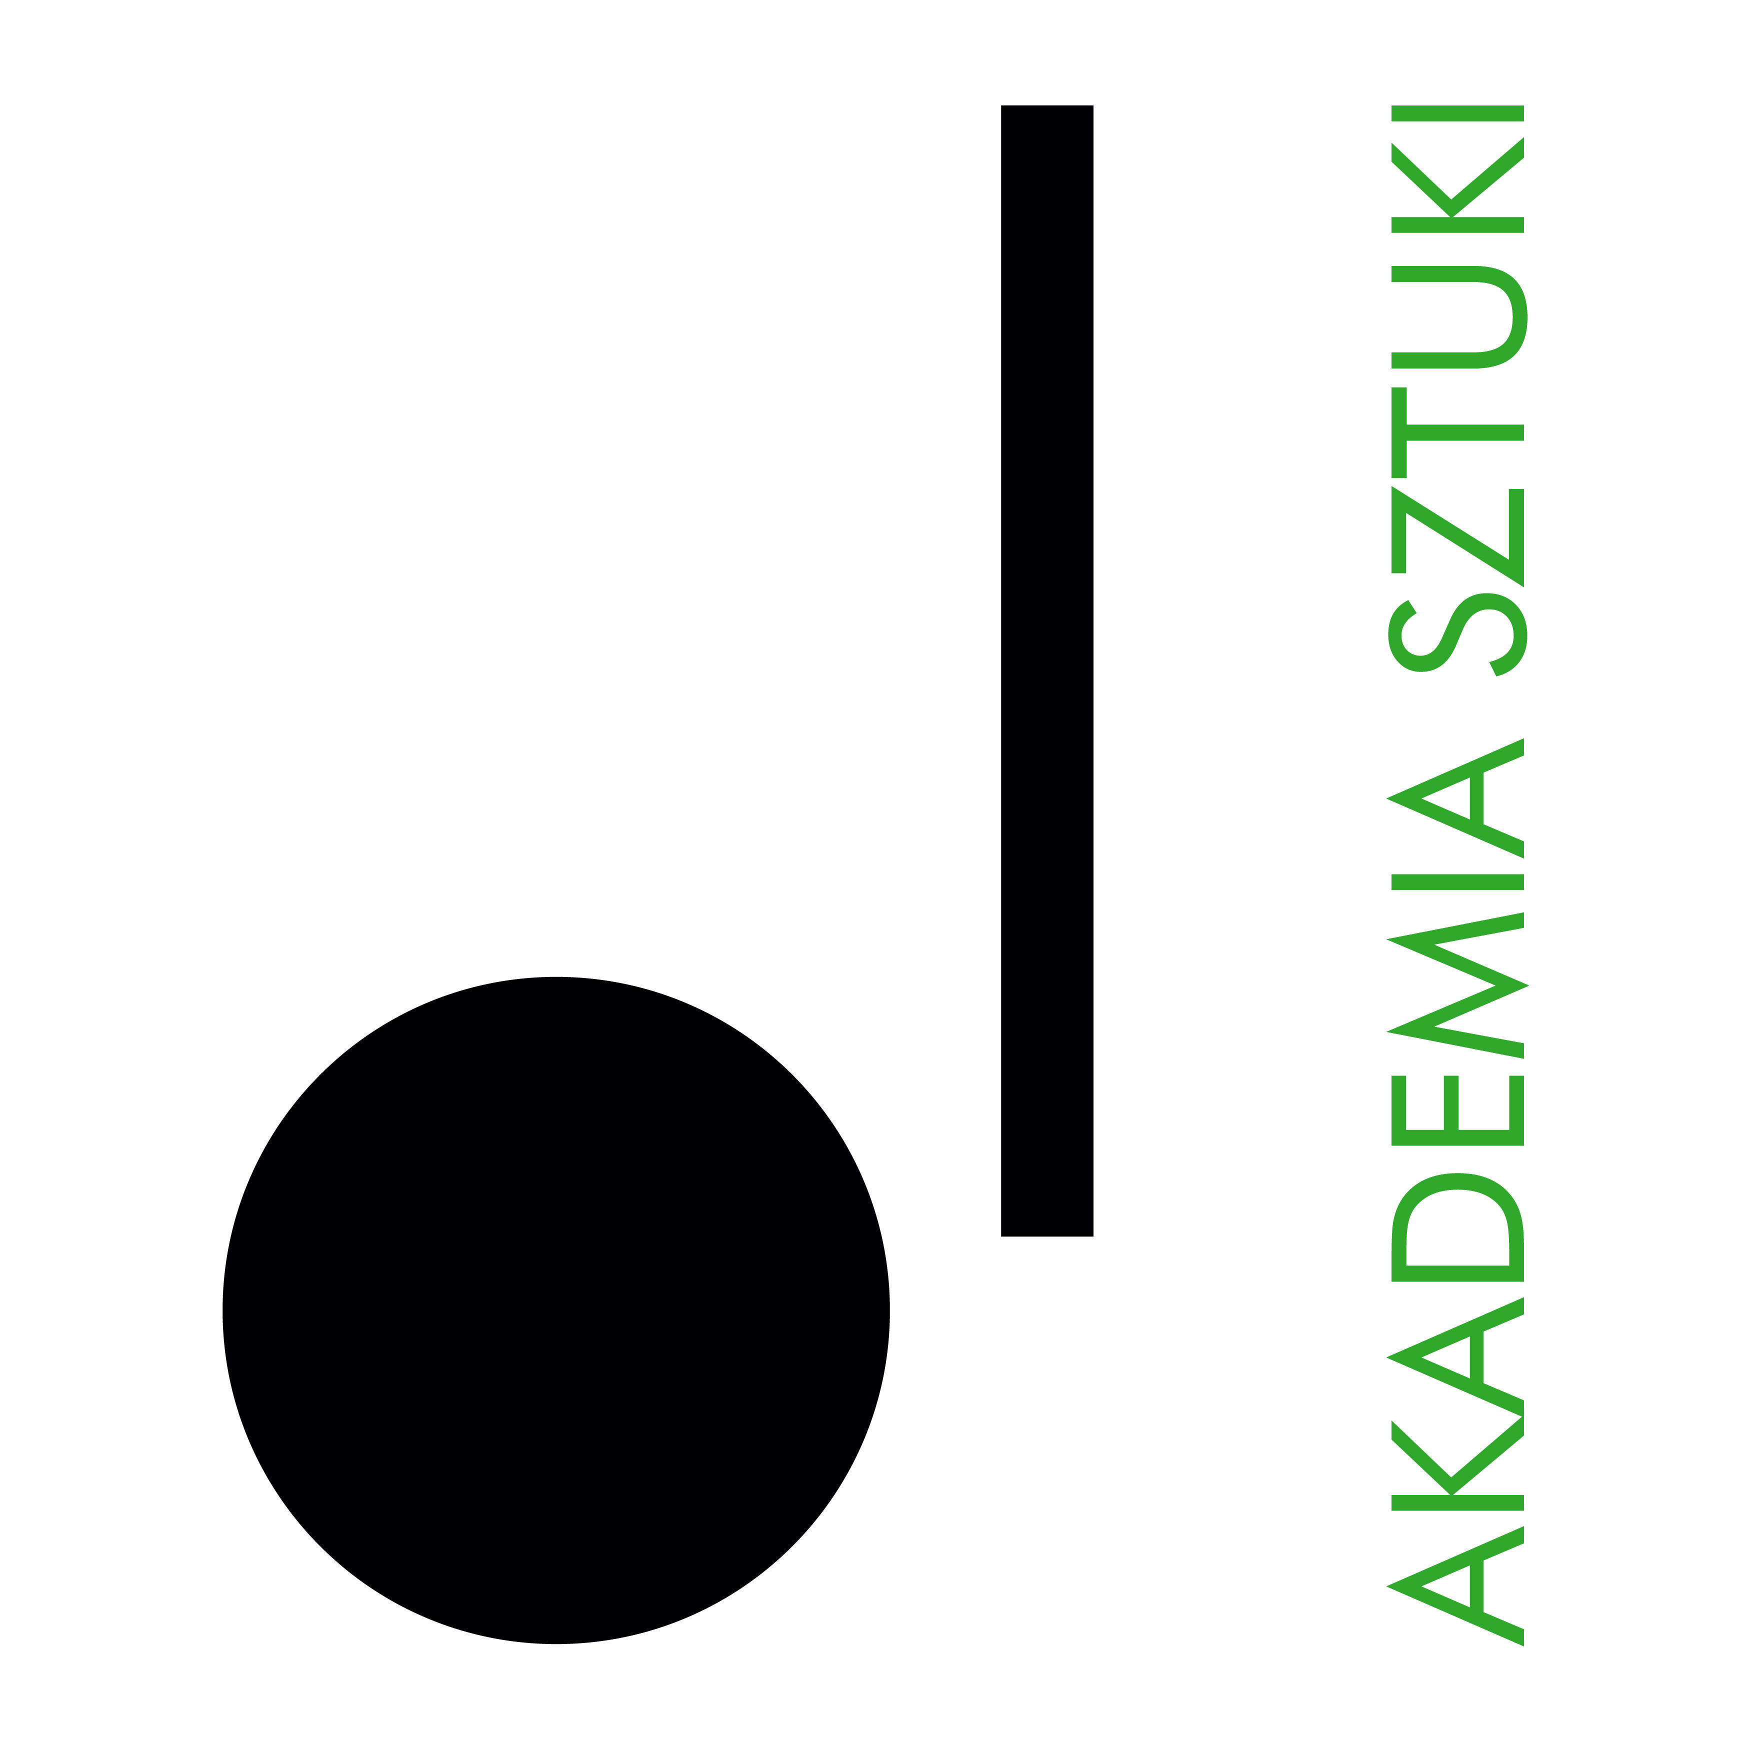

RECTOR
The Academy of Art in Szczecin announces an open competition for the position
Assistant Professor
in
Department of Product Design
at the Faculty of Design

At the Academy of Art in Szczecin, classes are conducted in Polish and take place on-site.

The competition may be entered by persons who meet the requirements specified in Art. 113 of the Act of
July 20, 2018 - Law on higher education and science (uniform text, Journal of Laws of 2023, item 742, as amended) and meet the following qualification criteria:

- an active professional designer with a PhD in the discipline of fine arts and art conservation,
- artistic achievement and activity in the field of design, documented by a portfolio,
- possesses teaching competencies and experience working with students – experience in conducting classes
at universities and/or academies,
- proficiency in English.

Required documents:

- application for participation in the competition,
- professional CV and personal questionnaire,
- copy of doctoral diploma,
- description of artistic achievements supported by documentation,
- a statement that the Academy of Art in Szczecin will be the primary place of work,
- declaration pursuant to Art. 113 of the Law on Higher Education and Science,
- any additional information (in the form of documents or publications that may be important in assessing additional skills related to the outcome of the competition).
- In the case of foreigners applying for employment under the competition, knowledge of Polish is required.

The deadline for submitting applications is: 02.07.2025 r.
Please send your applications by e-mail to: anna.marcinkowska@akademiasztuki.eu
Documents received by the Academy of Art in Szczecin after the above-mentioned deadline will not be considered (the date of receipt is decisive).
Selected candidates who qualify for the second stage of recruitment will be invited to an interview. Candidates will be informed about the date and place of the meeting by e-mail.
Estimated date of the competition results: 18.07.2025 r.

Note: The Academy of Art reserves the right to reject offers without giving a reason.

It does not provide housing to candidates from outside Szczecin.

The following should be added to the application: "I consent to the processing of personal data contained in my job offer for the purposes necessary to carry out the recruitment process and after its completion, conducted by the Academy of Art in Szczecin based in Szczecin in accordance with the Act of May 10, 2018 on protection of personal data (Journal of Laws of 2018, item 1000, as amended)”.
PERSONAL DATA
The administrator of personal data is the Academy of Art in Szczecin, pl. Orła Biały 2, 70-562 Szczecin. The Data Protection Inspector at the Academy of Art is available at the following e-mail address: iod@akademiasztuki.eu. The data is processed pursuant to Art. 6 section 1 letter e of the General Data Protection Regulation of April 27, 2016, hereinafter referred to as GDPR, in order to perform the information function. (The administrator does not share data or transfer data to a third country/international organization). The data will be stored for the time necessary
to achieve the purpose, maximum for the duration of the information function.
A person who has consented to the processing of personal data has the right to withdraw it at any time, which will not affect the lawfulness of the processing carried out on the basis of consent before its withdrawal.

The data subject has the right to access his or her data, correct it, rectify it, delete it, limit processing, transfer it and lodge a complaint with the supervisory authority.

The data will not be subject to automated processing, including profiling. Providing data is voluntary, but necessary to achieve the indicated purpose

