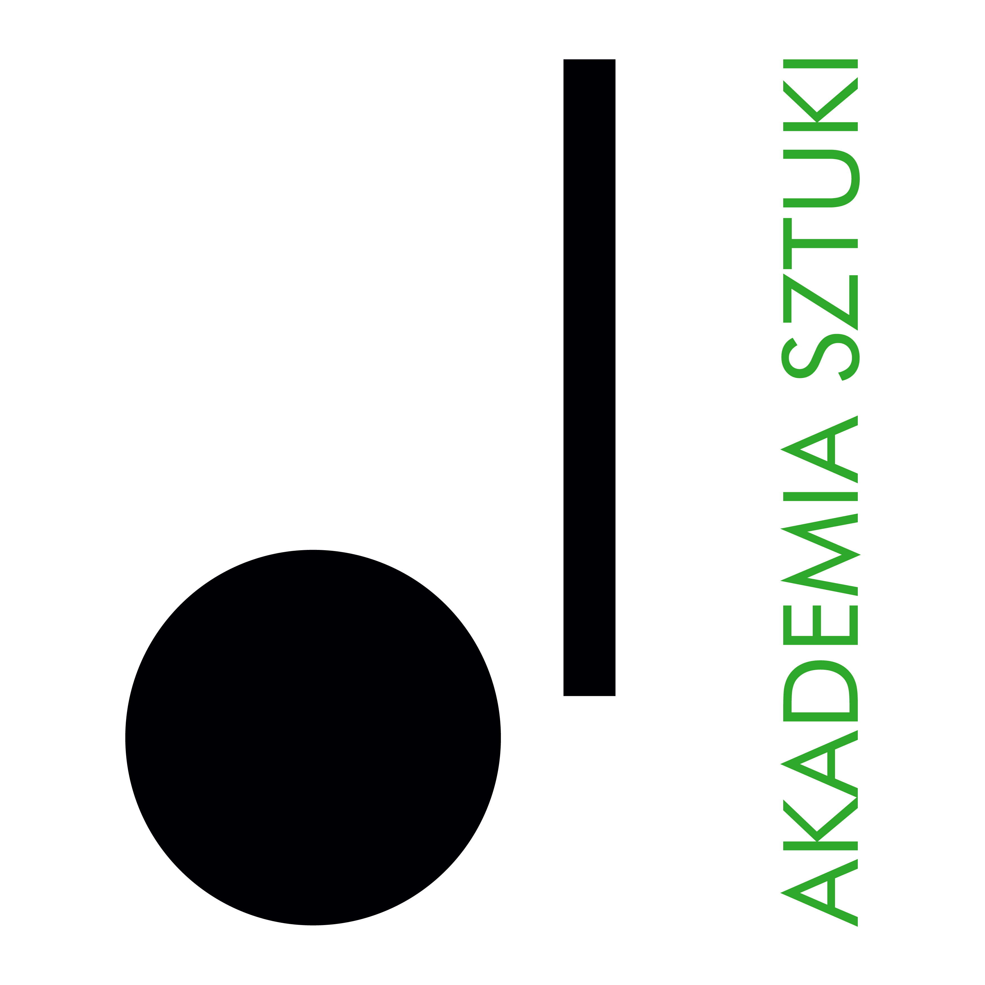

DSP-KON-111-7/2025/MR

**RECTOR**

**of The Academy of Art in Szczecin announces an open competition for the position of INSTRUCTOR/ACCOMPANIST**

**in the discipline: Conducting**

**in the Conducting Department**

**The competition is open to persons who meet the requirements set out in Article 113 of the Act of 20 July 2018. - Law on Higher Education and Science (consolidated text Dz. U of 2024, item 1571 as amended) as well as the following eligibility criteria:**

* graduated from higher education in the field of instrumental studies, specializing in playing the piano or piano chamber music.
* have experience of working as an accompanist/tutor
* have a good „a vista” music notes-reading ability
* show achievements in artistic and didactic activities,
* knowledge of Polish and English is required

**Required documents:**

* application for participation in the competition,
* professional resumé,
* a copy of the diploma with confirmation of academic degree,
* personal questionnaire for a person applying for employment (attachment),
* statement of the academic teacher (attachment),
* description of artistic achievements supported by documentation, portfolio
* a statement that the Academy of Art in Szczecin will be the primary place of work,
* any additional information (in the form of documents or publications that may be relevant to the assessment of additional skills related to the outcome of the competition).

**The closing date for applications is: 12 July 2025**

Documents received by the Academy of Art in Szczecin after the deadline specified above shall not be considered (the date of receipt is decisive).

**Anticipated date of concluding the competition:** 14 July 2025

**Announcement of competition results**: 18 July 2025

Selected candidates who qualify for the second stage of recruitment, which will take place on 14 July 2025, will be invited to an interview. Candidates will be informed about the time and place of the meeting by e-mail. During the job interview, your ability to play the piano a vista may be verified.

**Submission of the required documents by email to:** [sylwia.urdas@akademiasztuki.eu](mailto:sylwia.urdas@akademiasztuki.eu)

Please note: The Academy of Art does not provide accommodation for candidates from outside Szczecin.

In the application please add the disclaimer:

"I consent to the processing of the personal data contained in my job offer for the purposes necessary for the recruitment process and thereafter, conducted by the Academy of Art in Szczecin, based in Szczecin in accordance with the Act of 10 May 2018 on the protection of personal data (Journal of Laws of 2018, item 1000, 1669, of 2019, item 730)".

PERSONAL DATA

The administrator of personal data is the Academy of Art in Szczecin, pl. Orła Białego 2, 70-562 Szczecin. The Data Protection Officer at the Academy of Art can be reached at the e-mail address: iod@akademiasztuki.eu. The data are processed on the basis of Article 6(1)(e) of the General Data Protection Regulation of 27 April 2016, hereinafter referred to as RODO for the purpose of the information function. (The controller does not share the data or transfer the data to a third country/international organisation). The data will be stored for the time necessary to fulfil the purpose, up to a maximum of the duration of the provision of the information function.

The data subject shall have the right to withdraw his or her consent to the processing of personal data at any time, which shall, however, not affect the lawfulness of the processing carried out on the basis of consent before its withdrawal.

The data subject has the right to access, rectify, erase, restrict processing, transfer and lodge a complaint with a supervisory authority.

The data will not be subject to automated processing, including profiling. The provision of data is voluntary, but necessary to fulfil the indicated purpose.