DSP-KON-111-5/2025/MR

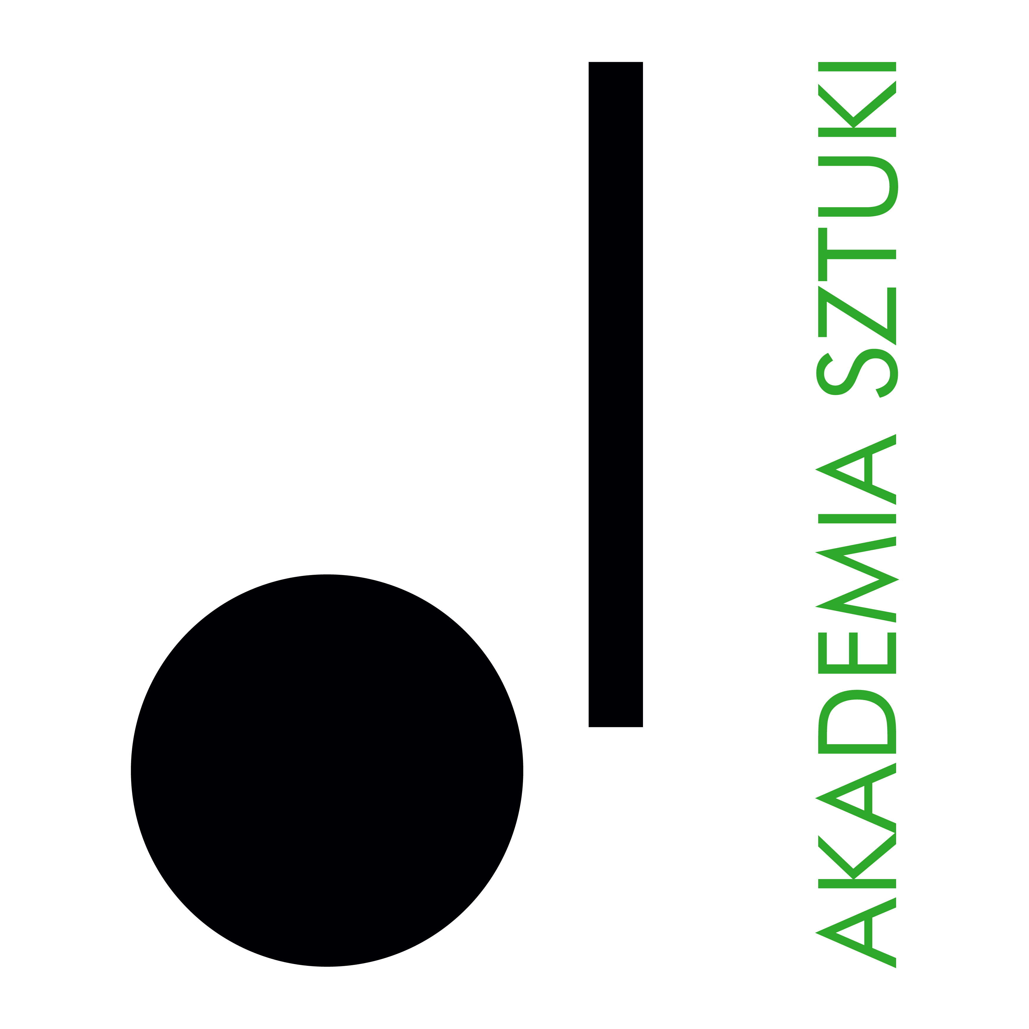

**RECTOR**

**of The Academy of Art in Szczecin announces an open competition for the position of**

**instructor/ca, full – time in the Department of Music Education**

**The competition is open to persons who meet the requirements set outin Article 113 of the Act of 20 July 2018. - Law on Higher Education and Science (consolidated text Dz. U of 2024, item 1571 as amended) as well as the following eligibility criteria:**

• have completed higher education in vocal and composition and have a master's degree,

• have a communicative knowledge of Polish and English

• have experience in teaching jazz vocal and composition/songwriting classes in higher music schools.

• is actively involved in artistic activities related to the field of jazz and vocal

• having permission to teaching subjects: Basics of composition with instrumentation, Songwriting, Jazz singing, Basics of improvisation for vocalists

**Required documents:**

* application for participation in the competition,
* professional resumé,
* a copy of the diploma with confirmation of academic degree,
* personal questionnaire for a person applying for employment (attachment),
* statement of the academic teacher (attachment),
* any additional information (in the form of documents or publications that may be relevant to the assessment of additional skills related to the outcome of the competition).

**The closing date for applications is: 12 July 2025**

Documents received by the Academy of Art in Szczecin after the deadline specified above shall not be considered (the date of receipt is decisive).

**Selected candidates** who qualify for the second stage of the recruitment process will be invited to an interview. Candidates will be informed of the date and place of the meeting via email.

**Anticipated date of concluding the competition:** 18 July 2025

**Announcement of competition results**: 21 July 2025

**Submission of the required documentsby email to: sylwia.urdas@akademiasztuki.eu;**

The winner of the competition immediately after the announcement the competition results shall submit the **original** documents to the following address: Akademia Sztuki w Szczecinie, pl. Orła Białego 2, 70-562 Szczecin, Dean’s Office, room 009

Please note: The Academy of Art does not provide accommodation for candidates from outside Szczecin.

Inthe application please add the disclaimer:

"I consent to the processing of the personal data contained in my job offer for the purposes necessary for the recruitment process and thereafter, conducted by the Academy of Art in Szczecin, based in Szczecin in accordance with the Act of 10 May 2018 on the protection of personal data (Journal of Laws of 2018, item 1000, 1669, of 2019, item 730)".

PERSONAL DATA

The administrator of personal data is the Academy of Art in Szczecin, pl. Orła Białego 2, 70-562 Szczecin. The Data Protection Officer at the Academy of Art can be reached at the e-mail address: iod@akademiasztuki.eu. The data are processed on the basis of Article 6(1)(e) of the General Data Protection Regulation of 27 April 2016, hereinafter referred to as RODO for the purpose of the information function. (The controller does not share the data or transfer the data to a third country/international organisation). The data will be stored for the time necessary to fulfil the purpose, up to a maximum of the duration of the provision of the information function.

The data subject shall have the right to withdraw his or her consent to the processing of personal data at any time, which shall, however, not affect the lawfulness of the processing carried out on the basis of consent before its withdrawal.

The data subject has the right to access, rectify, erase, restrict processing, transfer and lodge a complaint with a supervisory authority.

The data will not be subject to automated processing, including profiling. The provision of data is voluntary, but necessary to fulfil the indicated purpose.