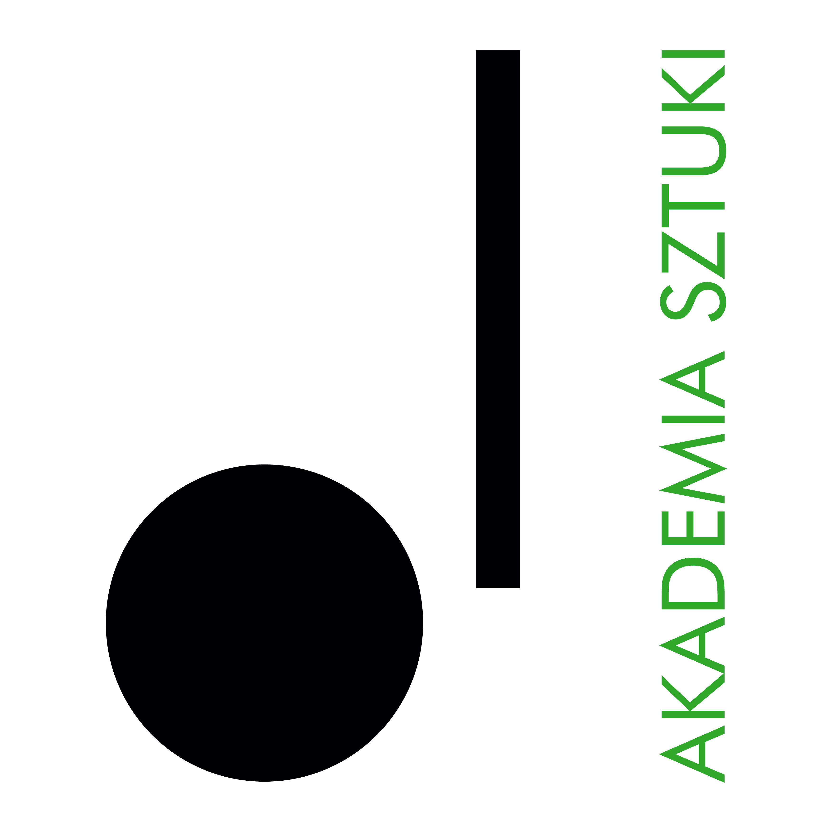

RECTOR
of the Academy of Art in Szczecin
announces an open competition for the position of
Assistant Professor
at the Department of Eksperimental Film
at the Faculty of Media Art, Photography, and Experimental Film

The competition is open to candidates who meet the requirements set forth in Article 113 of the Act of 20 July 2018 – Law on Higher Education and Science (consolidated text: Journal of Laws 2020, item 85, as amended), and who fulfill the following qualification criteria:

- hold at least a doctoral degree (PhD) in visual arts or film
- have a documented, significant artistic and/or film portfolio of at least 5 years
- have a command of English at level B2 sufficient to conduct teaching activities

Required documents:
- application for participation in the competition
- professional CV and personal questionnaire
- copies of Master’s and doctoral diplomas
- description of academic and artistic achievements supported by documentation
- declaration that the Academy of Art in Szczecin will be the primary place of employment
- declaration pursuant to Article 113 of the Law on Higher Education and Science
- any additional information (in the form of documents or publications relevant to the assessment of additional skills related to the competition outcome)
- in the case of foreign applicants, knowledge of the Polish language is required

List of courses to be taught following the competition outcome
- Basic Course of Experimental Film – 120 hours
- Course od Experimental Film – 120 hours

Application deadline: 13 June 2026
Documents received after this date will not be considered (the date of receipt is decisive).

Selected candidates who qualify for the second stage of recruitment will be invited for an interview. Candidates will be informed about the date and place of the meeting via email.

Expected date of competition resolution: by 17 June 2026
Announcement of results: 17 June 2026

Submission of documents: applications will be accepted exclusively in electronic form at: aleksandra.banaszyk@akademiasztuki.eu

Email subject line: COMPETITION FOR THE POSITION OF ASSISTANT PROFESSOR – Experimental Film

Note: The Academy of Art does not provide accommodation for candidates from outside Szczecin.

The application should include the following statement:
“I consent to the processing of my personal data contained in my job application for the purposes necessary to carry out the recruitment process and after its completion, conducted by the Academy of Art in Szczecin, in accordance with the Act of 10 May 2018 on the protection of personal data (Journal of Laws of 2018, items 1000, 1669, and of 2019, item 730).”

PERSONAL DATA

The controller of personal data is the Academy of Art in Szczecin, pl. Orła Białego 2, 70-562 Szczecin. The Data Protection Officer can be contacted at: iod@akademiasztuki.eu.

Data are processed on the basis of Article 6(1)(e) of the General Data Protection Regulation of 27 April 2016 (GDPR) for the purpose of fulfilling the information function. The controller does not share or transfer data to third countries or international organizations.

Data will be stored for the period necessary to achieve the purpose, no longer than the duration of fulfilling the information function.

A person who has given consent to the processing of personal data has the right to withdraw it at any time, without affecting the lawfulness of processing carried out on the basis of consent before its withdrawal.

The data subject has the right to access their data, rectify, correct, delete, restrict processing, transfer data, and lodge a complaint with a supervisory authority.

Data will not be subject to automated processing, including profiling. Providing data is voluntary but necessary to achieve the stated purpose

