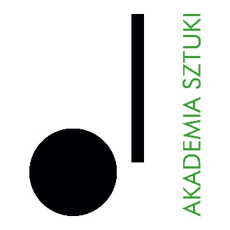

RECTOR
of The Academy of Art in Szczecin announces an open competition for the position of
INSTRUCTOR Part-time job (0,875)
in the discipline: musical arts specialty piano
in the at the Department of Piano, Harpsichord, and Organ in the Instrumental Faculty
The competition is open to persons who meet the requirements set out in Article 113 of the Act of 20 July 2018. - Law on Higher Education and Science (consolidated text Journal of Laws of 2024, item 1571 as amended) as well as the following eligibility criteria:
• possession of a master's degree in art
• having significant artistic achievements
• speaking Polish and English at a level that allows conducting educational classes
• having experience working as a pianist and accompanist
Required documents:
• application for participation in the competition,
• professional resume and personal questionnaire,
• copy of graduation diplomas,
• description of significant artistic achievements supported by documentation
• declaration pursuant to art. 113 of the Law on Higher Education and Science,
• any additional information (in the form of documents or publications that may be important in assessing additional skills related to the outcome of the competition).
The closing date for applications is: 01.09.2026
Documents received by the Academy of Art in Szczecin after the deadline specified above shall not be considered (the date of receipt is decisive).
Selected candidates who qualify for the second stage of the recruitment process will be invited to an interview. Candidates will be informed of the date and place of the meeting via email.
Anticipated date of concluding the competition: 03.09.2026
Announcement of competition results: 07.09.2026
Submission of the required documents by email to: marta.oblegor@akademiasztuki.eu;
The winner of the competition immediately after the announcement the competition results shall submit the original documents to the following address: Akademia Sztuki w Szczecinie, ul. Niepodległości 40, 70-704 Szczecin, Dean’s Office, room 09
Please note: The Academy of Art does not provide accommodation for candidates from outside Szczecin.

Inthe application please add the disclaimer:
"I consent to the processing of the personal data contained in my job offer for the purposes necessary for the recruitment process and thereafter, conducted by the Academy of Art in Szczecin, based in Szczecin in accordance with the Act of 10 May 2018 on the protection of personal data (Journal of Laws of 2018, item 1000, 1669, of 2019, item 730)".
PERSONAL DATA
The administrator of personal data is the Academy of Art in Szczecin, pl. Orła Białego 2, 70-562 Szczecin. The Data Protection Officer at the Academy of Art can be reached at the e-mail address: iod@akademiasztuki.eu. The data are processed on the basis of Article 6(1)(e) of the General Data Protection Regulation of 27 April 2016, hereinafter referred to as RODO for the purpose of the information function. (The controller does not share the data or transfer the data to a third country/international organisation). The data will be stored for the time necessary to fulfil the purpose, up to a maximum of the duration of the provision of the information function.
The data subject shall have the right to withdraw his or her consent to the processing of personal data at any time, which shall, however, not affect the lawfulness of the processing carried out on the basis of consent before its withdrawal.
The data subject has the right to access, rectify, erase, restrict processing, transfer and lodge a complaint with a supervisory authority.
The data will not be subject to automated processing, including profiling. The provision of data is voluntary, but necessary to fulfil the indicated purpose.

